NEXGEN biolab
Bioinformatics Projects

Participant Name  Fatimah Al-Mohammed | Email Address  fatimah0almohammed@gmail.com

TASK | Binding Site Prediction

Objective: To identify and characterize the primary binding site of protein using DoGSiteScorer on the raw (unprepared) protein.

📖 | Method Summary:  Binding site prediction identifies druggable cavities on a protein surface based on geometric and physicochemical properties. DoGSiteScorer (proteins.plus) uses a Difference of Gaussians (DoG) filter to detect pockets and score them by size, hydrophobicity, and druggability. Using the raw (unmodified) protein for this step ensures the prediction reflects the native structure, avoiding artefacts introduced during preparation.

Important
Use the RAW PDB file for this task — NOT the prepared version. DoGSiteScorer works best with the unmodified structure.

▸ Task Steps
1 | Go to DoGSiteScorer via proteins.plus (https://proteins.plus) and click 'DoGSiteScorer'.
2 | Upload the raw PDB file (or enter PDB ID directly).
3 | Select Chain A (if other chains are present) only in the submission options.
4 | Run the prediction and wait for the results.
5 | Identify the top-ranked binding pocket (Pocket P_0 or highest-scored).
6 | Record the pocket score, volume, surface area, and key residues.
7 | Open PyMOL and load the binding pocket. Manually select and highlight the binding site residues.
8 | Take PyMOL screenshots showing the pocket surface and labelled residues.

Binding Site Summary

Parameter | Value / Description
Top Pocket ID | e.g., P_0
Pocket Volume (Å³) | 1292.16
Pocket Surface Area (Å²) | 1576.77
Druggability Score | 0.81

Binding Site Residues Table
List any 5 residues identified in the binding pocket. Include residue name, number

# | Residue Name | Residue Number
1 | LEU | 22
2 | ALA | 9
3 | VAL | 8
4 | ILE | 7
5 | GLU | 30

PyMOL Binding Site Visualizations

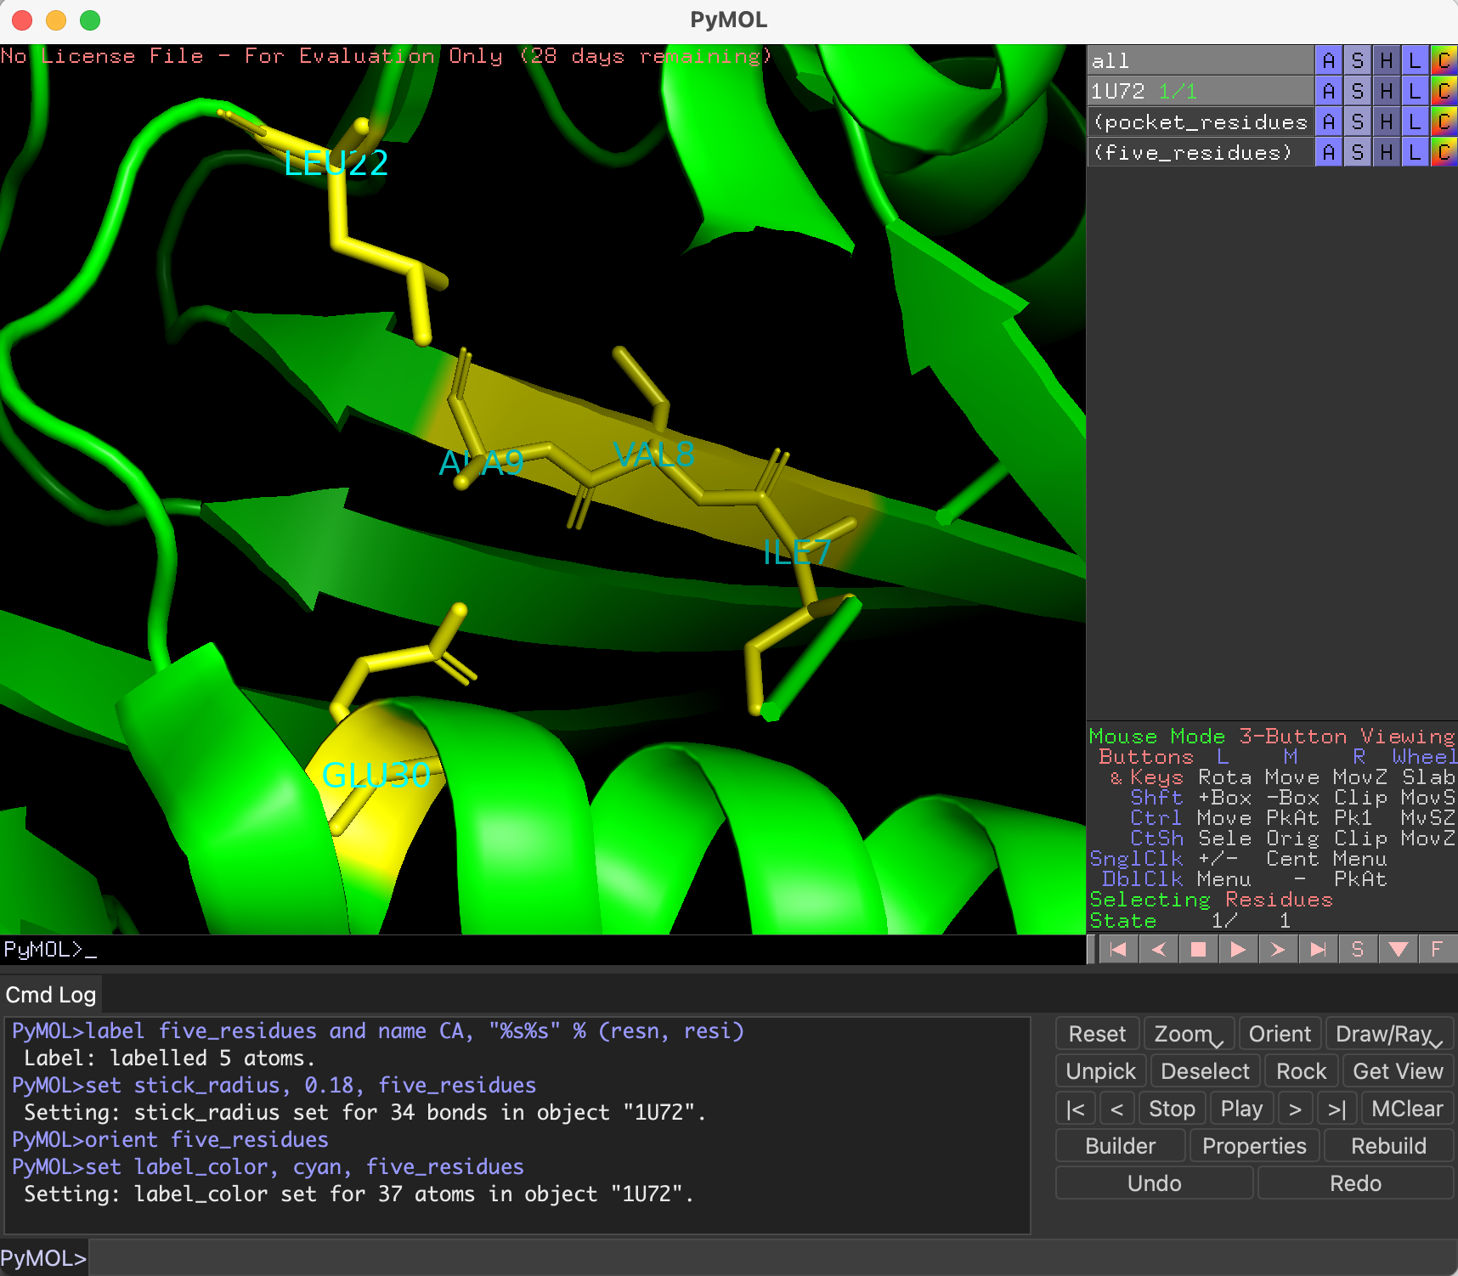

Binding Pocket Surface View (PyMOL)

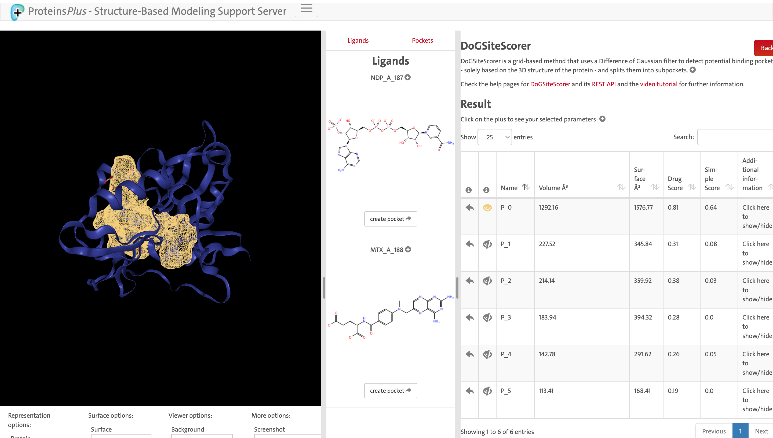

DoGSiteScorer Results Screenshot (proteins.plus website)

Written Justification
Describe the identified binding site. What characteristics make it a good drug target?

The predicted binding site (P_0) is a large pocket with a volume of 1292.16 Å³, surface area of 1576.77 Å², and a high druggability score of 0.81. Its size and physicochemical properties suggest that it can accommodate small-molecule ligands and support different types of molecular interactions. Therefore, P_0 is considered a promising potential drug-binding site for further investigation.

